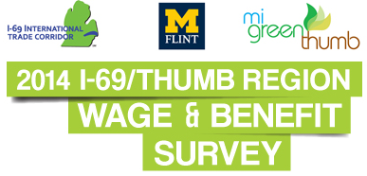

FREQUENTLY ASKED QUESTIONS

What is the purpose of the Regional Wage & Benefit (W&B) Survey?
The Regional W&B survey was designed to gain insights on wage and benefit practices at companies located in the seven-county region known as the I-69/Thumb. The region includes Shiawassee, Genesee, Lapeer, St. Clair, Tuscola, Sanilac and Huron counties.

Who conducted the survey?
This first-of-its-kind survey was conducted by the Flint & Genesee Chamber of Commerce and the University of Michigan-Flint, along with economic development partners in the I-69 International Trade Corridor and the Thumb counties.

What will businesses learn from the final report?
The reports will provide data for area firms to determine their competitiveness as it relates to wages and benefits. Economic development agencies will also use the findings to inform prospective businesses of wage expectations in the region.

What companies participated?
One hundred seventy (170) companies that do business in the seven-county region completed the survey.

What sectors are represented in the study?
A large majority of the respondents are manufacturers. Other sectors that are represented include health care, education, IT and logistics/transportation.

When was the survey conducted?
The survey was conducted in the spring of 2014.

How many reports will be produced?
There will be seven editions available: Each edition includes an aggregate, seven-county report (I-69/Thumb); a sub-region report (i.e., I-69 Corridor); and a county report (i.e., Genesee County).

How can I receive a copy of the reports?
To obtain the Genesee County edition, which includes the 2014 I-69/Thumb Regional Wage and Benefit Survey, I-69 International Trade Corridor Survey and Genesee County Survey visit (link). The three-report set is available for $75. For more information contact Janice Karcher, Vice President of Economic Development for the Chamber at (810) 600-1429 or jkarcher@flintandgenesee.org.

