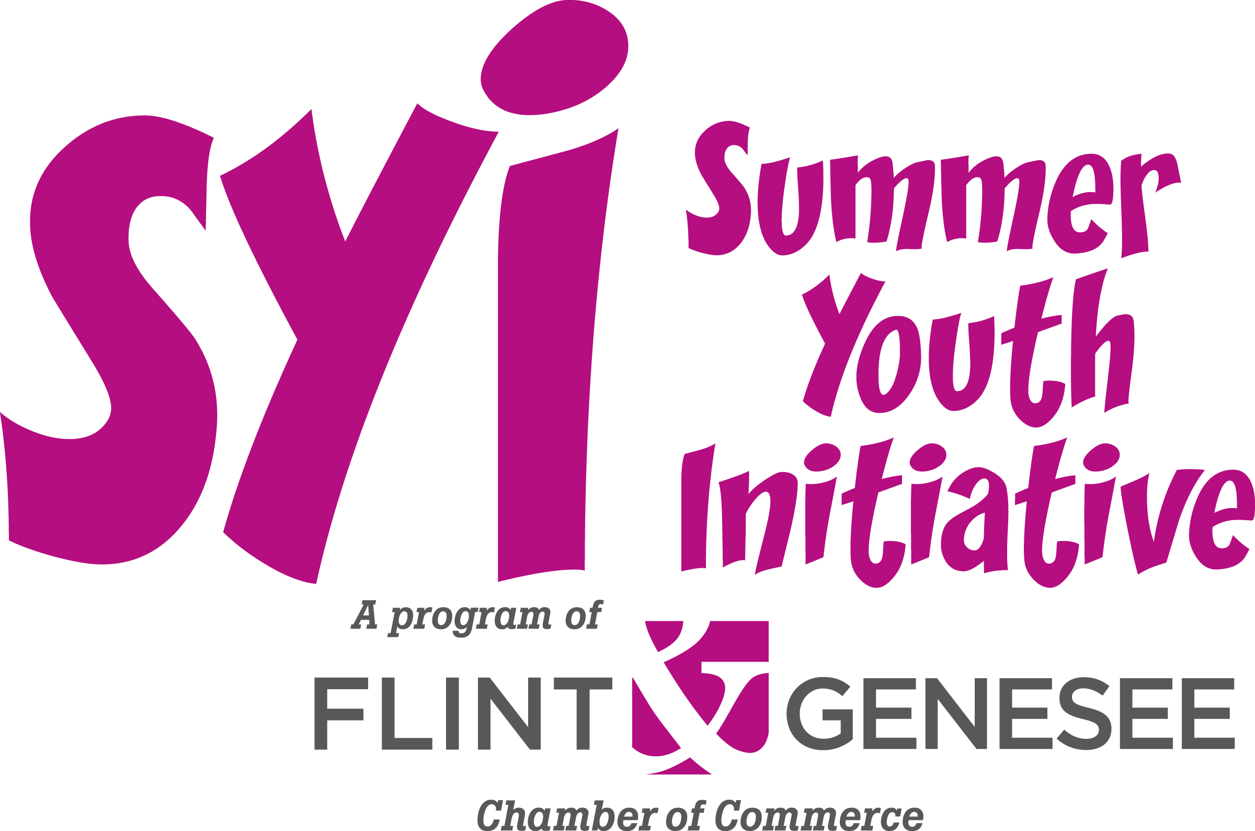
Important Dates to Remember

Application Due
March 27, 2015

Job Fair
April 25, 2015

Dear Student,

Thank you for your interest in the Summer Youth Initiative (SYI). SYI is a training and employment program for Genesee County in-school youth who meet the following criteria:

- Age 14-18 and currently in the 9th-12th grade. You must meet both age and grade level requirements.
- Live in Genesee County and attend a Genesee County school (includes public, private, charter, alternative and home schools)
- Have successfully completed the TeenQuest Pre-Employment Leadership Training through the Flint & Genesee Chamber of Commerce. If you have not completed TeenQuest, please contact (810) 600-1413 to apply.

If you meet the criteria above, complete the attached SYI 2015 Application to be considered for employment opportunities. Applications are due Friday, March 27, 2015. Mail or deliver your application to the Flint & Genesee Chamber of Commerce, 519 S. Saginaw, Suite 200, Flint, MI 48502. Mailed applications with a postmark of no later than March 27, 2015 will be accepted. You may also fax your application to (810) 600-1463.

The application is attached for you to complete and return to the Chamber by March 27, 2015. You must submit an application to SYI and attend the Job Fair each year to be considered for employment. You will receive a letter inviting you to the SYI Job Fair a few weeks before the event. If you change your address, please contact our office at (810) 600-1413 so that we can update your information. If you have any questions, you may contact the Chamber via email at syi@flintandgenesee.org or (810) 600-1413.

Sincerely,


Rhetta Hunyady
Vice President, Education & Training
Important Dates to Remember

Application Due
March 27, 2015

Job Fair
April 25, 2015

2015 Summer Youth Initiative Student Application

Date: ______________

Name: __________________________________________________________________
(Last) (First) (Middle)

Address: __________________________________________________________________
(Number & Street) (City) (Zip code)

Telephone: Home_______________________ Cell_________________________________

Email address______________________________________________________________

Emergency Contact:____________________________ ___________________________
(Name of contact person) (Telephone)

Do you have the legal right to work and remain in the United States? __ Yes __ No

Birthdate: ___________ Name of your school: _________________________

What grade are you in? 9th 10th 11th 12th 12th-2nd year (circle one)

Free/Reduced Lunch Eligibility: __ Yes __No (This is informational only. It will not determine eligibility.)

Do you have transportation to the worksite? ___ Yes ___ No

Do you have any reason to believe that you cannot perform the essential job functions with or without accommodations? ___ Yes ___ No
If you need accommodations, please list what kind: __________________________________________________________________________________________________________________________________________________

Have you ever been discharged, asked to leave, or suspended from middle or high school?
___Yes ___ No If yes, please explain in detail _________________________________
________________________________________________________________________
________________________________________________________________________

Have you ever been convicted of any violation of the law other than minor traffic violations? __Yes __ No If yes, please explain in detail_____________________________________
________________________________________________________________________
________________________________________________________________________

Have you previously been employed through the Summer Youth Initiative Program?
___ Yes ___ No If yes, list the name of the employer you worked with below:
________________________________________________________________________

Work Experience: List below all present and past employment beginning with your most recent job. Please list on a separate sheet any additional information and attach it with your application.

Company: _________________________________ Supervisor__________________________
Address: _______________________________City: ______________________________
Telephone: _______________________
Starting Date: _________________Ending Date: _________________________________
Position: __________________________ Reason for Leaving:_______________________

Company: _________________________________ Supervisor__________________________
Address: _______________________________City: ______________________________
Telephone: _______________________
Starting Date: _________________Ending Date: _________________________________
Position: ________________________Reason for Leaving:_________________________

Are you currently employed? ___ Yes ___No Work hours: _________________________
Do you anticipate having a second summer job in addition to SYI? ___ Yes ___ No

Please list other skills, talents, and abilities that you have. This could include any artistic, musical, computer, athletic, leadership skills, etc.
__________________________________________________________________________________________________________________________________________________

Please list any present or past volunteer experience. If none, please print “None” below.
__________________________________________________________________________________________________________________________________________________

Please list any present or past extracurricular activities (sports, clubs, student council, etc.). __________________________________________________________________________________________________________________________________________________

Other Commitments:
Please check any other planned summer activities that may conflict with the Summer Youth Initiative work experience. If none, please check “None” below.
____Summer vacation ____Drivers training ____Other
____Sports practices ____Summer camp ____Family Reunion
____Summer school ____College visits ____None

Date of activity:___________________________________________________________

Employment Opportunities
Each year, several nonprofit agencies are selected to be the “employers” for the Summer Youth Initiative Program. Below is a list of the types of jobs that may be available through these employers. Please select your top three choices (number them 1, 2, 3). While we are asking you to select your top three choices, we reserve the right to make any changes.

___ Community Beautification Assistant. You will work in community parks and other public areas with clean-up, recycling and planting activities.

___ Kids Club Assistant. You will work with young children in five core areas including academics, recreation, health, arts, and character development.

___ Community Garden Assistant. Your work assignments will include cultivating, nurturing and harvesting produce to be sold to the general public.

___ Sports Assistant. You will be assisting in preparing the ball field for games, officiating and coaching players ages 4-15 years old.

___ Library Assistant. You will be working on research projects, organizing materials, helping with the reading club and assisting young children.

___ Food Bank Assistant. You will be packaging and sorting food, personal items and meals for at risk children and families in the community.

___ General Office Assistant. You will work in an office setting, answering phones, filing, collating materials, typing, and other office assignments.

___ Special Needs Assistant. You will work with disabled adults to provide a variety of activities to assist them in their goal to live, work and participate in the community as normally and as independently as possible.

Other employment opportunities may also be available through other area employers. Please check the ones you have an interest in from the list below:

___ Retail stores ___ I’m open to any job.
___ Fast Food/Restaurant ___ Packaging and shipping materials
___ General office ___ Grocery store

SYI Employee Agreement:
All students who are applying for SYI employment must agree to the following:

- Attend the SYI Job Fair. Exceptions will be made for any teen who is hospitalized or whose religion observes Saturday as a holy day. Written proof will be required to be considered for opportunities that become available following the SYI Job Fair.
- If you are hired through SYI, you are responsible to obtain a work permit from your school and provide it to your employer prior to your first day of work.
- Volunteer one day of service through the SYI Volunteer Service Day. If you are unable to participate on the planned volunteer day, you can meet this requirement by volunteering with a local nonprofit agency and submitting a letter to the Chamber from the agency confirming your service during the summer.
- You may be offered a job by several employers; however, you can only accept one job offer.

I understand the three things listed above and agree to complete all of the requirements.

Signature required

You want to be in the Summer Youth Initiative because:
The Flint & Genesee Chamber of Commerce and the SYI Employer Agencies would like to know why you want to be in the Summer Youth Initiative Program. Please write a brief paragraph below that explains in your own words why you want this job. If you do not answer this section, your application will be incomplete and will not meet the program criteria.
________________________________________________________________________________________________________________________________________________________________________________________________________________________________________________________________________________________________________________________________________________________________________________________________________________

CERTIFICATION: By signing and submitting this form, I certify that this application is complete and all information provided is true and accurate and contains no willful falsifications or misrepresentations. I understand that falsifications or misrepresentations will disqualify me from consideration for employment.

Signature: ________________________________ Date: ______________

ALL APPLICATIONS ARE DUE by Friday, March 27, 2015.
THERE WILL BE NO EXCEPTIONS
Mail or deliver your application to:
Flint & Genesee Chamber of Commerce
Attn: Summer Youth Initiative
519 S. Saginaw, Suite 200
Flint MI 48502
Or Fax to 810-600-1463

